Written by Tiffany Floyd

340 words

**al-Attar, Suad (1942-)**

Bornin Baghdad, Iraq, Suad al-Attar moved to London in 1976. She holds a prominent position within the narrative of Iraqi modern and contemporary art as one of the nation’s leading female artist. In 1965, al-Attar became the first woman to hold a solo exhibition in Baghdad. This exhibition was the beginning of a prolific career that spans several decades and geographic regions. Al-Attar began her formal education at the Academy of Fine Arts in Baghdad and at California State University. She then pursued graduate training in London at the Wimbledon School of Art, where she studied printmaking, and the Central School of Art and Design. After the completion of her studies, al-Attar taught at the University of Baghdad before moving to London. Working within a graphic aesthetic, al-Attar’s work is flat, linear, and oftentimes monochromatic. Her canvases are filled with mythical creatures set in phantasmagoric spaces. The artist’s work is characterized as a manifestation of memory, at both a personal and collective level. Her characters emerge from Iraq’s literary past, but al-Attar also creates a personalized set of symbols based on memories of her homeland. Many of her works are also introspective laments on the destruction of Baghdad during the turbulent years of the 1990s and 2000s.

Despite the somewhat esoteric nature of al-Attar’s paintings, her work is appreciated by a wide audience. She continues to exhibit prodigiously and has received many accolades during her long career. Al-Attar’s work is held in prestigious collections like the British Museum and the Arab Museum of Modern Art in Doha, Qatar.

**References and Further Reading**

Albemarle Gallery. *Suad Al-Attar.* London:Albemarle Gallery.

# “Art and Artist Suad AlAttar Asmahan Alkarjosli” YouTube.com, 2013. <http://www.youtube.com/watch?v=wM2DPsqokjU> (accessed February 21st, 2014).

Kalsi, Jyoti. “Dreaming of a Better World,” *Gulf News*, December 7, 2006.

<http://gulfnews.com/arts-entertainment/visual-performing-arts-2.313/dreaming-of-a-better-world-1.39799>

Porter, Venetia*. Word Into Art: Artists of the Modern Middle East*. London: The British Museum Press, 2006.

Qabbani, Nizar and Angus Stewart*. Suad Al-Attar*. Trans. By Suheil Bushrui. London: Al-Madad Foundation, 2004

## The British Museum Online. “Suad al-Attar (Iraq-UK), Inspiration from a poem, hand coloured soft-ground etching and aquatint artist's proof,” britishmuseum.org, 2014. <https://www.britishmuseum.org/explore/online_tours/museum_and_exhibition/word_into_art/suad_al-attar_iraq-uk,_inspi.aspx> (accessed February 21st, 2014).

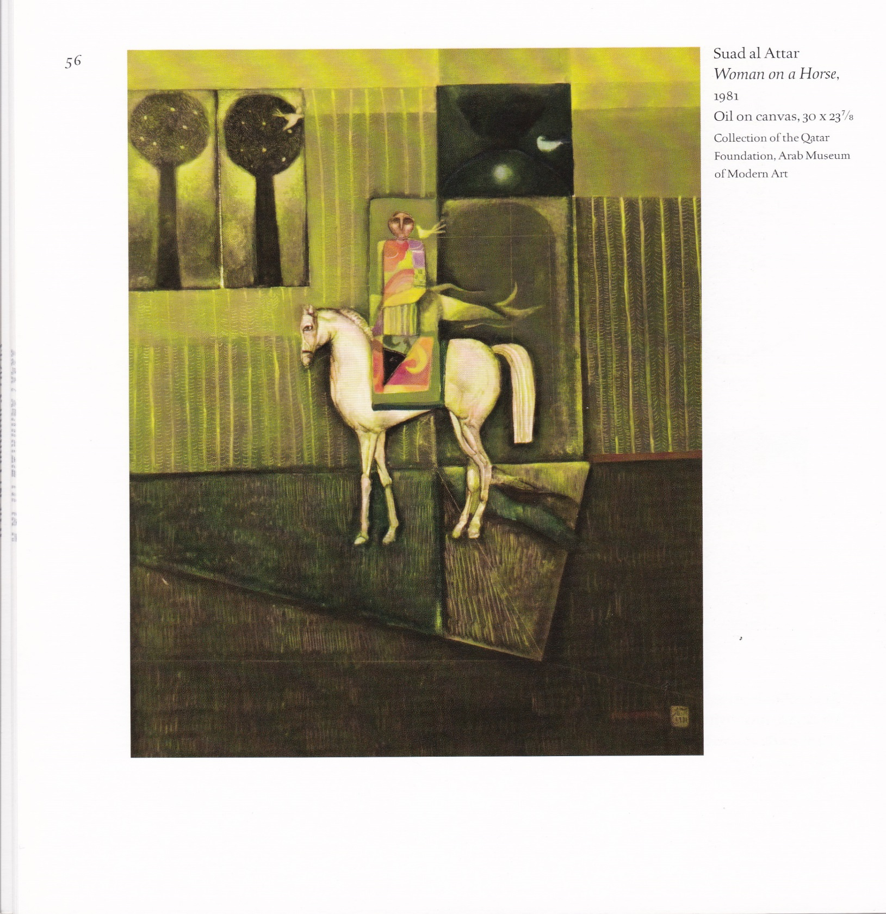

Suad al-Attar

Woman on a Horse, 1981

Oil on Canvas

30 X 23 1/8

Collection of the Qatar Foundation

Mathaf: Arab Museum of Modern Art